21 Crankshaft End Play Measurement
TRANSFR Inc. Diesel Part 2

Sim General Information
Sim Description: | Trainee will check and correct crankshaft end play.
Mentor: | AutomotiveSimon | Other Characters: | N/A
Character Voices: | Simon (Jas)
SME: | Mark DeHart | ID Designer: | Original design: Kelly Murphy  Updated by: Amy Chamberlain
Copy Editor: | Tasha Tchetchetkine | ID Designer: | Original design: Kelly Murphy  Updated by: Amy Chamberlain
ID Dev Support: | TBD | Epic Link: | SIMDEV-280
Teleporting: | No | VO Folder: | [insert VO Folder Link]

Learning Objectives
- Don appropriate PPE (step 2)
- Prepare crankshaft for measurement (steps 3, 9)
- Activate and install magnetic base and dial indicator (steps 4, 10)
  - Activate magnetic base. (steps 4,10)
  - Install magnetic base and dial indicator on crankshaft (steps 4, 10)
- Measure crankshaft end play (steps 5, 10)
- Correct crankshaft end play (steps 6, 11)

Playspace

Play Space A
[Trainee is in the diesel shop. There’s a truck with its hood open in the bay (outside of playspace).
Engine has been removed and is floating in front of trainee. The bottom of the engine is facing the trainee at waist height. It’s oriented so that the crankshaft runs horizontally. The back of the engine is on the trainee’s left and the front of the engine is on the trainee’s right. The oil pan is removed. There is a steel cart to the right of the trainee.]
Top Down (with play space bounding box)  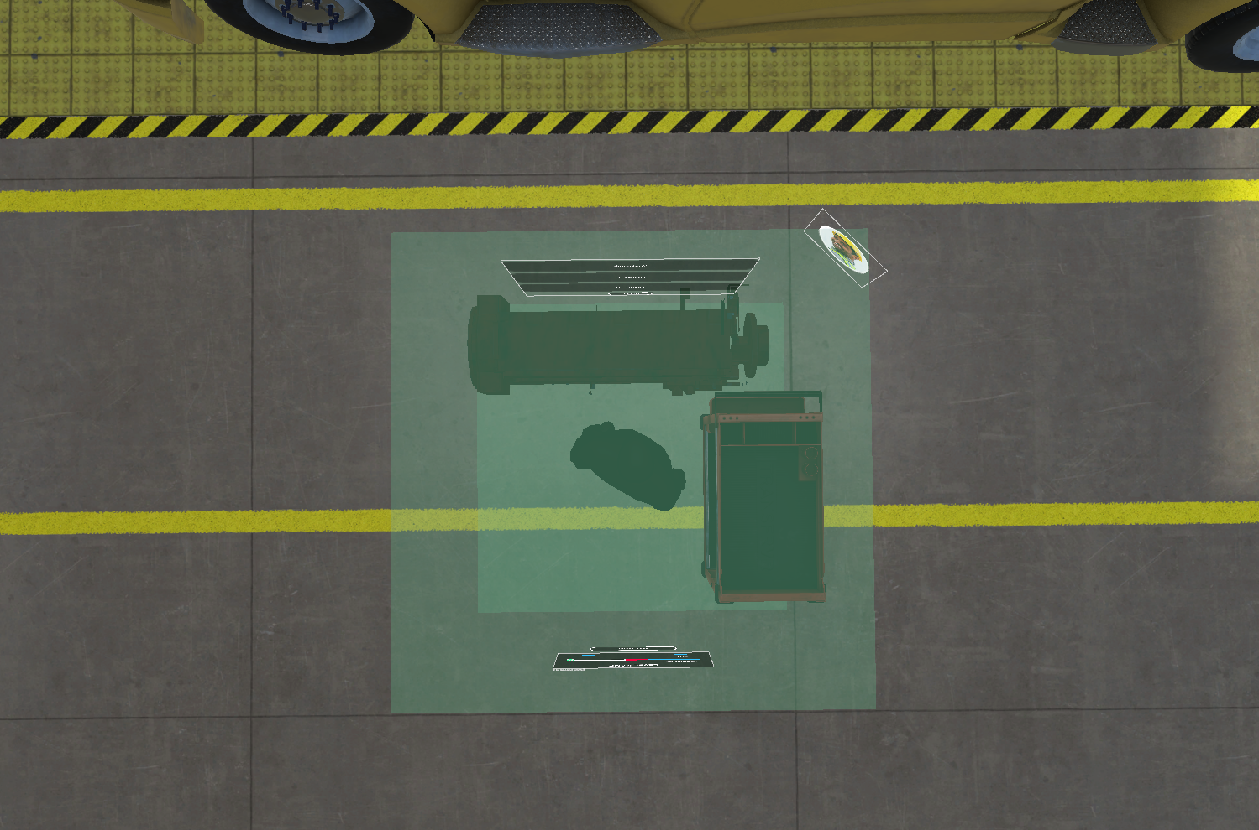 | Trainee View (trainee from the back)  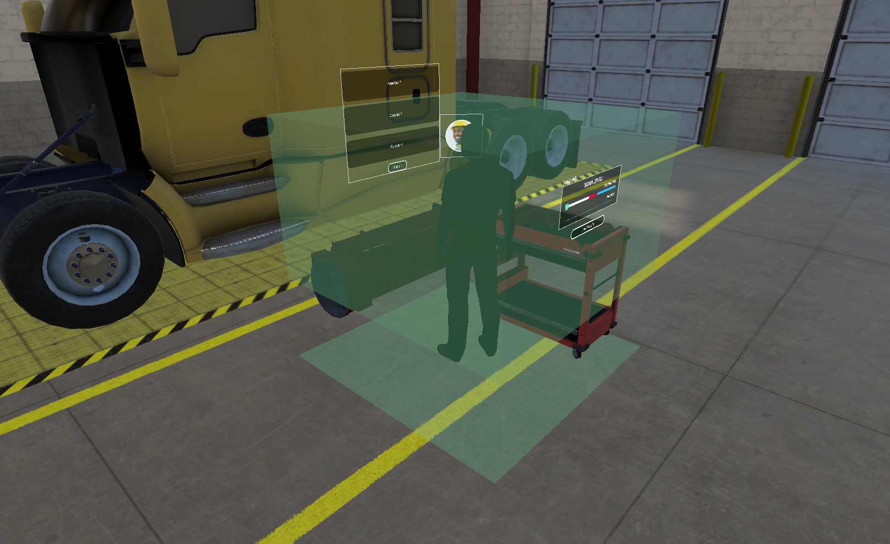
Perspective (clear view of UI elements)  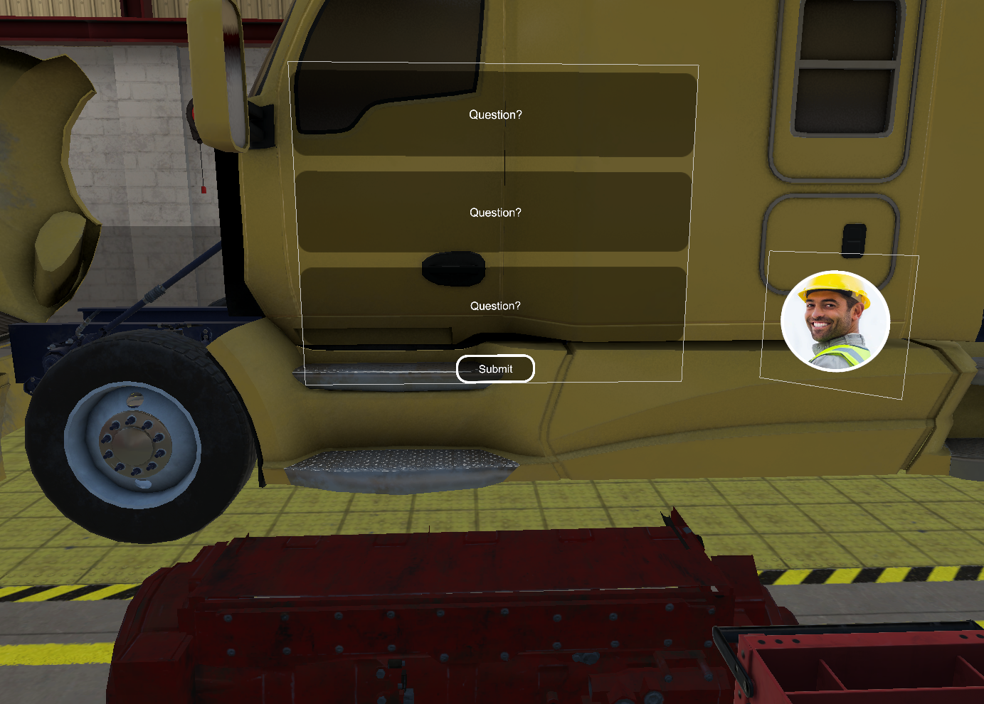 | Side (trainee from right and/or left side)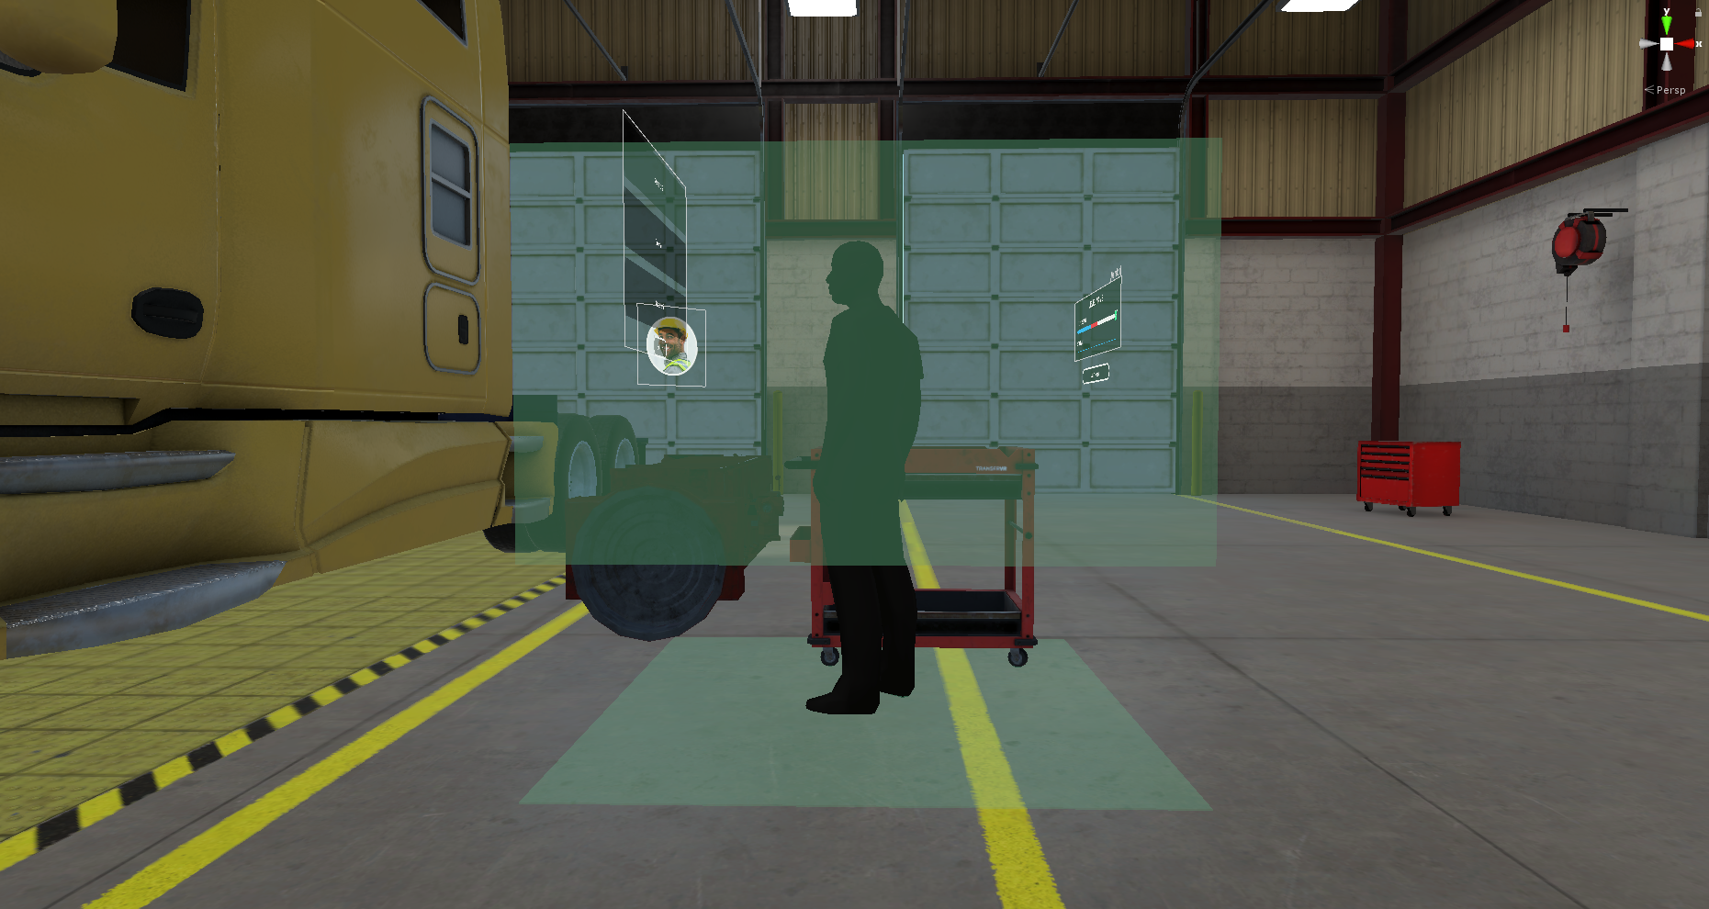

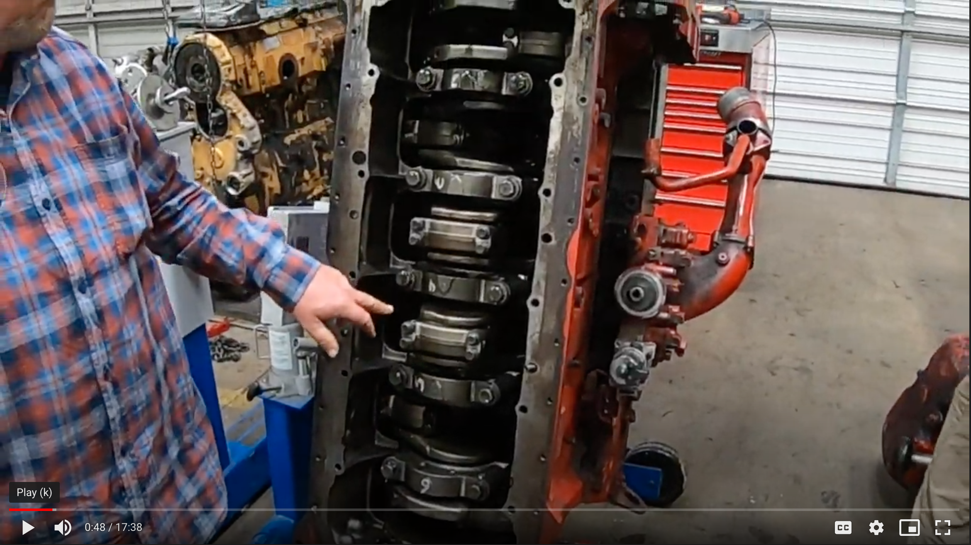
Ref: bottom of engine; rotated vertically on a rotator; with oil pan removed. Timestamp 0:48.

Assets
Name | Image | Dev Notes | GitHub Link
Safety glasses | 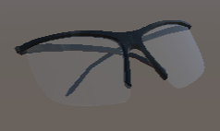 | Interactive: Yes
Ear plugs | 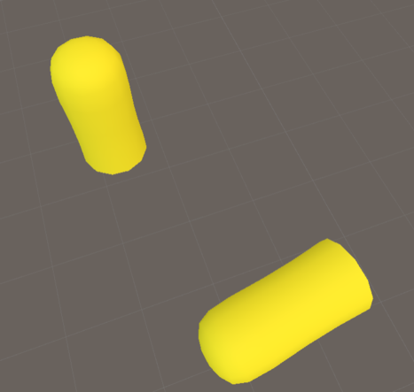 | Interactive: Yes
Black gloves | 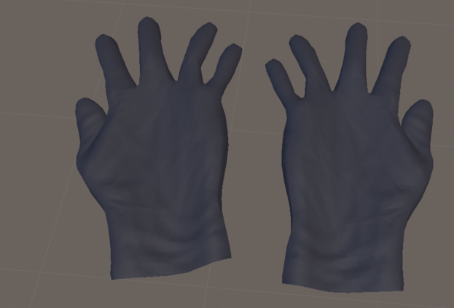 | Interactive: Yes
Magnetic base and dial indicator assembly | 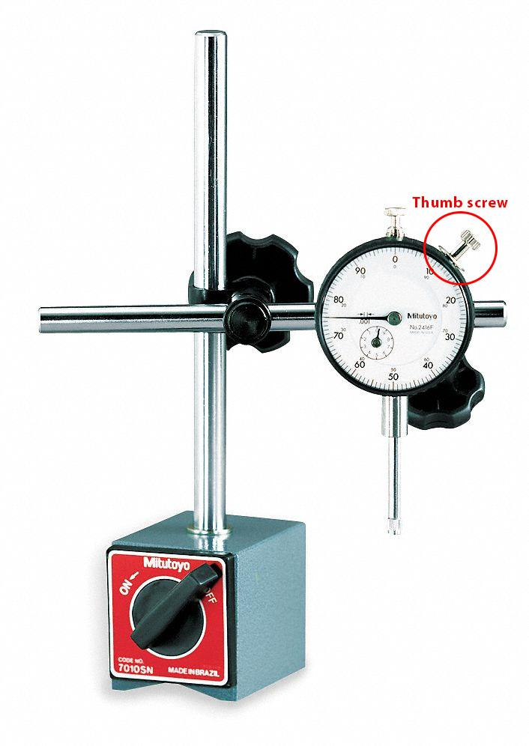  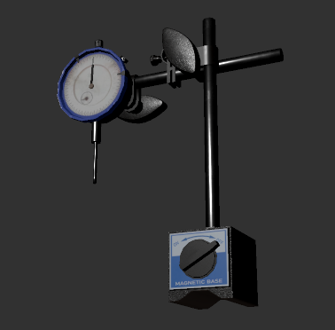 | Interactive: Yes
Pry bar | 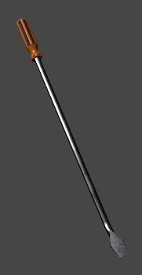 | Interactive: Yes
Ratchet | 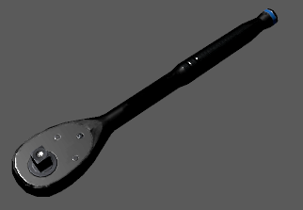 | Interactive: Yes
Socket | 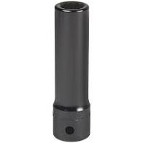 | Interactive: Yes  Size: 21 mm
Torque wrench, digital | 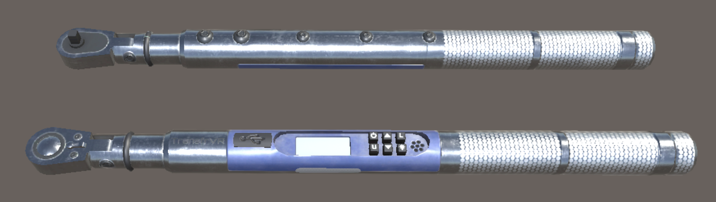 | Interactive: Yes  [sfx digital torque wrench] - this plays when the wrench is turned to its target angle  [sfx socket wrench] - this plays on the wind back of the wrench (wrong direction)  [sfx long warning beep] - This long beep plays when the user tries to turn too far | This tool has a lot of known bugs. Please refer to this Jira ticket: https://transfrvr.atlassian.net/browse/VS-53
Mag UI | 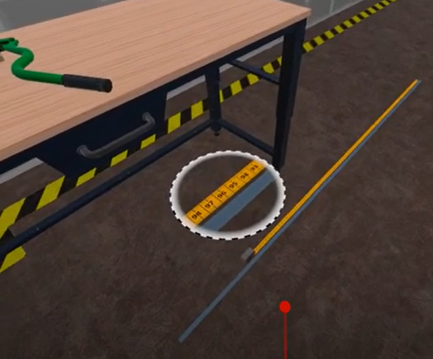 | Interactive: No
Work Cart | 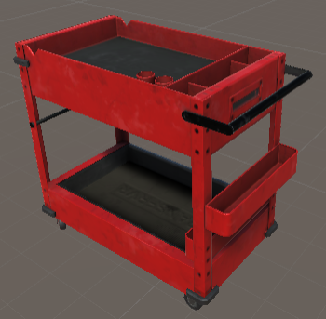 | Interactive: No

SFX
- [sfx confirmation]
- [sfx fist hit desk]
- [sfx metal clang]
- [sfx buzzer]
- [sfx digital torque wrench]
- [sfx socket wrench]
- [sfx long warning beep]

Global Behaviors
- Refer to Frontend Design Guidance for play space guidelines and other high-level guidance for how to implement front end design.
- Idle conditional timing
- Play [sfx pop] any time an object first spawns OR respawns
- Grabbed objects always persist in trainee hand unless otherwise specified (in other words, objects never disappear from the hand)
- Dropped items respawn on the cart

Tutorial

1. Introduction (Tutorial)
Domain model success criteria: | Reach the end of this step.  (Do not add mistakes within this step.)
[Play space A]

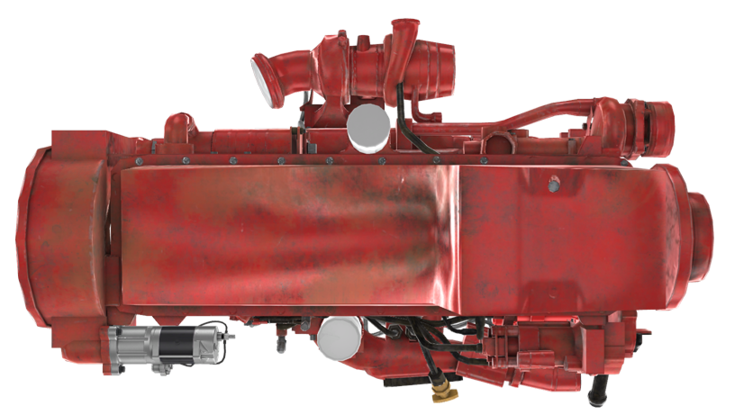
[reference image for bottom of engine, which should be facing trainee, but with cover removed]
[reference image of bottom of engine, which faces up towards the trainee]

[Simon VO:] Welcome to the shop! Today we’ll be measuring crankshaft end play, which is the total distance the shaft can move between the thrust bearings.

2 PPE (Tutorial)

Domain model success criteria: | Reach the end of this step.  (Do not add mistakes within this step.)

Developers and VO Maintenance: Please insert the PPE (Tutorial) from the Diesel 2: PPE and Engine Rotation Standards document.

3 Prepare Crankshaft For Measurement (Tutorial)
Domain model success criteria: | Reach the end of this step.  (Do not add mistakes within this step.)

[Simon VO:] We gotta push the crankshaft toward the rear of the cylinder block before we can measure its end play.

[Pry bar appears on cart]
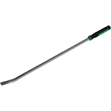
[reference image of pry bar]

[Simon VO:] When we take our measurement, we’ll use the pry bar to push the crankshaft towards the FRONT of the cylinder block to see how far it moves.
[pulse highlight the pry bar]
[Simon VO:] Pick up the pry bar.

 | Action “Do” | Visual “See” | VO / SFX “Hear” | Haptic “Feel” | Dev Notes
Correct: | Picks up pry bar |  | [sfx confirmation]
If: | Idle |  | [Simon VO:] Pick up the pry bar.

[reference image of pry bar in crankshaft]

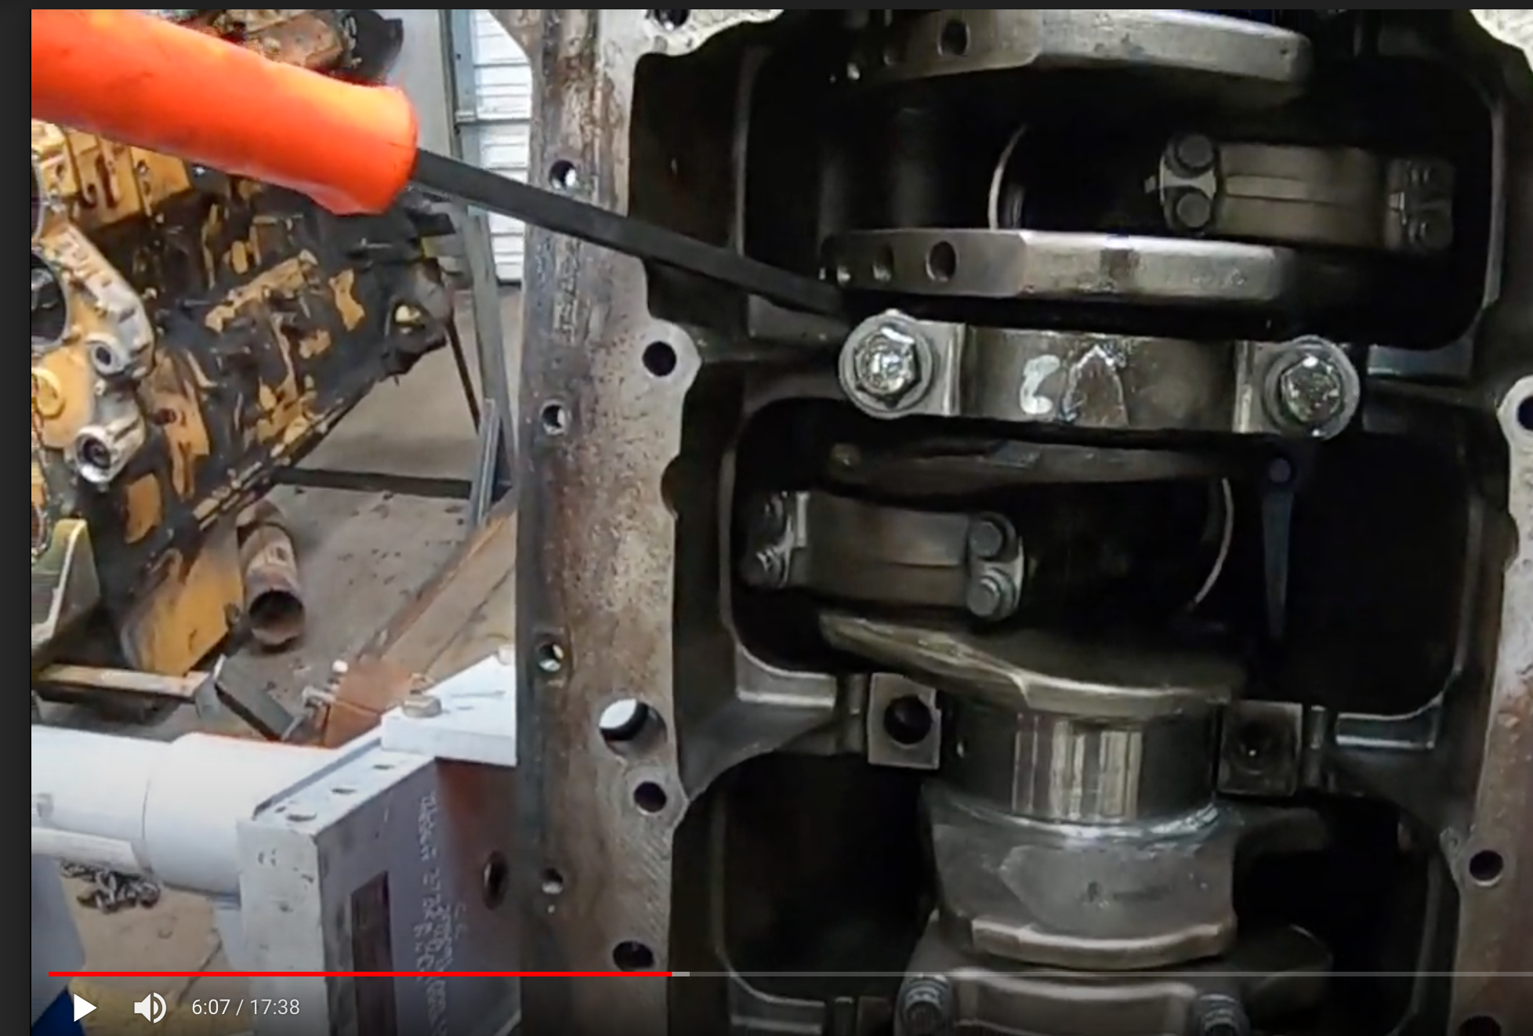
[reference image of pry bar wedged in between the counterweight (to the left of the pry bar) and main bearing cap #3 (to the right of the pry bar)]

[reference video showing two possible correct pry bar positions: https://www.youtube.com/watch?v=u2e288ISk2Q 0:20-0:28]

[Ghost pry bar appears, positioned between the counterweight and bearing cap that’s easiest to access for trainee] (see image above)]

[Simon VO:] Wedge it in here, between this counterweight and cap. You can put the pry bar between any of the counterweights and bearing caps, but we’re using this one right now.

 | Action “Do” | Visual “See” | VO / SFX “Hear” | Haptic “Feel” | Dev Notes
Correct: | Places pry bar on ghost pry bar | [appear right arrow indicator above pry bar] | [sfx confirmation]
If: | Idle |  | [Simon VO:] Place the pry bar where I’m showing you.

Rear of engine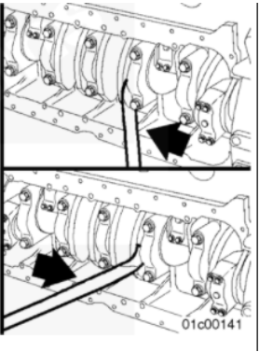Front of engine

[reference image of pry bar shifting crankshaft to rear of engine]

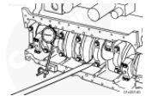

[reference image of pry bar position with crankshaft toward the rear of the engine]

[Simon VO:] Great! Now, push the handle of the pry bar to the right to shift the crankshaft to the rear.

 | Action “Do” | Visual “See” | VO / SFX “Hear” | Haptic “Feel” | Dev Notes
Correct: | Pushes bar to the right | [animation: crankshaft shifts toward the rear of the engine about one inch] | [sfx confirmation]  [sfx metal clang] | [haptic feedback in controller holding pry bar]
If: | Idle |  | [Simon VO:] Push the handle of the pry bar towards the front of the engine.
If: | Pushes pry bar to the left |  | [Simon VO:] Oops! Not that way.

[Simon VO:] Put the pry bar down on the cart.

 | Action “Do” | Visual “See” | VO / SFX “Hear” | Haptic “Feel” | Dev Notes
Correct: | Puts down pry bar |  | [sfx confirmation]  [sfx metal clang]
If: | Idle |  | [Simon VO:] Put the pry bar down on the cart.

[vanish pry bar]

4. Activate and Place Dial Indicator (Tutorial)

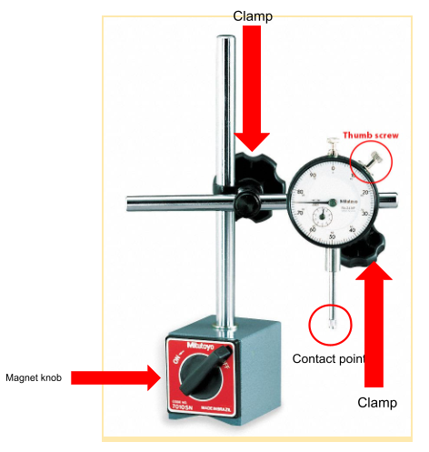
needle
[reference image for parts of magnetic base (the block at the bottom) and dial indicator assembly]

[Magnetic base with attached dial indicator appears on the cart. Knob is set to “off,”; needle is set to 0]
[Simon VO:] We’ll use this dial indicator and magnetic base to measure the crankshaft’s end play.
[pulse highlight magnetic base]
[Simon VO:] There’s a powerful magnet built into the base to lock the dial indicator in place.
[end pulse highlight magnetic base]
[Simon VO:] We’re working on a steel cart today, so I can show you how it works.
[Simon’s hand appears (non-transparent), animate the hand knocking on the cart twice]
AND
[sfx fist hit desk (use first hit twice, synchronized with animation)]
[Simon VO:] Turning on the magnetic base secures the entire unit to the cart.
[pulse highlight knob on the magnetic base]

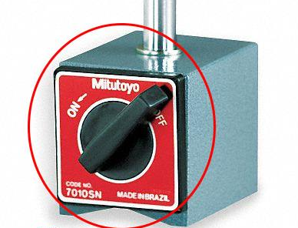

[reference image of knob on magnetic base]

[Simon VO:] Grab the knob on the magnet.

 | Action “Do” | Visual “See” | VO / SFX “Hear” | Haptic “Feel” | Dev Notes
Correct: | grabs the knob | [appear counterclockwise hint UI arrows]  [pulse highlight disappears] | [sfx confirmation]
If: | Idle |  | [Simon VO:] Grab the knob on the magnet.

[Simon VO:] Turn on the magnetic base by switching the knob to ON.

 | Action “Do” | Visual “See” | VO / SFX “Hear” | Haptic “Feel” | Dev Notes
Correct: | Rotates knob counter-clockwise until it’s set to ON | [counterclockwise hint UI arrows disappear]  [knob snaps into place pointing to ON and won’t move farther] | [sfx confirmation]
If: | Idle |  | [Simon VO:] Turn on the magnetic base by switching the knob to ON.

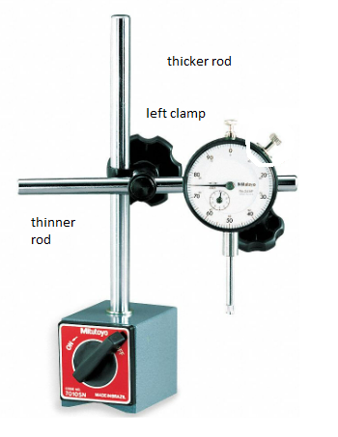

Right clamp

[reference image of dial indicator’s two rods and clamps]

[Simon VO:] The magnetic base comes with two rods…
[pulse highlight thicker rod (the vertical one)]
[Simon VO:] …a thicker one that attaches to the base…
[end pulse highlight vertical rod]
[pulse highlight thinner rod (the horizontal one)]
[Simon VO:] …and a thinner one that attaches to the dial indicator.
[end pulse highlight thinner rod (the horizontal one)]
[Simon VO:] Each rod has a clamp. We’ll adjust the clamps to move the dial in different directions.

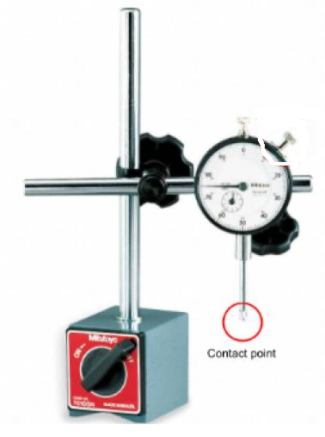

[reference image of contact point]

[Simon VO:] Here’s how to use this gauge to measure small movements, like the side-to-side movement of the crankshaft within the engine block.
[pulse highlight contact point]
[Simon VO:] This contact point will touch the crankshaft counterweight. As you move the counterweight, the contact point and the needle will move. The needle measures these movements in thousandths of an inch.
[end pulse highlight contact point]
[Simon VO:] Notice what happens to the needle when the pry bar moves the crankshaft.

[appear 3D animation floating above the cart.
Details: animate the scene here https://www.youtube.com/watch?v=iAUMLVB4C2o from 11:17 to 11:20. We need to see:
- The crowbar moving slightly
- The needle on the gauge jumping to the 10]

[the animation should start with the gauge oriented like this:]
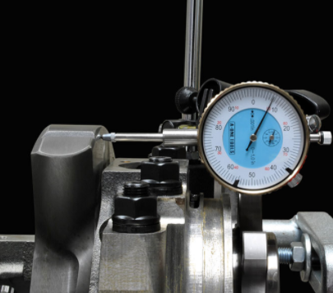

[Simon VO:] If the needle moves too far, or not far enough, we’ll need to make some adjustments so that the crankshaft has the right amount of wiggle room–or endplay.
[Simon VO:] Now that the crankshaft is towards the rear, we can place the dial indicator assembly.

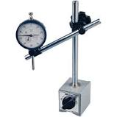
[reference image of dial indicator and magnetic base]

[state change: knob on magnetic base switches to OFF]
[pulse highlight dial indicator and magnetic base]
[Simon VO:] I’ve switched the magnet off. Grab the dial indicator assembly.
 | Action “Do” | Visual “See” | VO / SFX “Hear” | Haptic “Feel” | Dev Notes
Correct: | Picks up assembly | [appear ghost dial indicator/magnetic base assembly on engine, as in reference image below] | [sfx confirmation]
If: | idle |  | [Simon VO:] Pick up the dial indicator assembly.

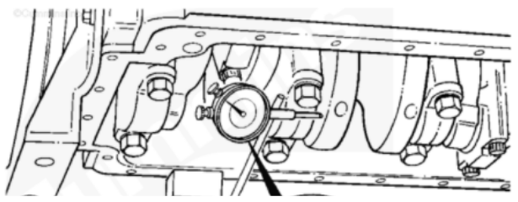

Magnetic base (on oil flange)
Contact point placed correctly on crankshaft’s counterweight. For ghost assembly, contact point should be close to, but not touching, this counterweight.
[reference images of dial indicator positioned correctly on leftmost counterweight on crankshaft]

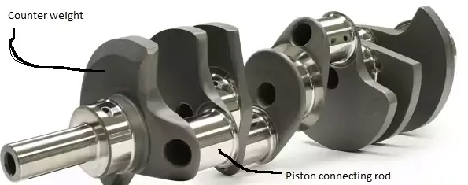
[Reference image of counterweight]

[Simon VO:] Put the whole assembly right here.
 | Action “Do” | Visual “See” | VO / SFX “Hear” | Haptic “Feel” | Dev Notes
Correct: | Puts assembly on ghost assembly | [dial indicator/magnetic base assembly “snaps” into place] | [sfx confirmation]
If: | idle |  | [Simon VO:] Put the magnetic base and dial indicator assembly here.

[pulse highlight knob on magnetic base]

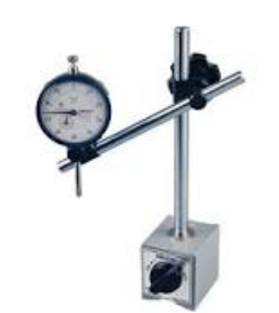
Knob on base
[reference image of knob on magnetic base]

[Simon VO:] Now, turn the knob on the magnetic base. When it’s on, the assembly will stay put.

 | Action “Do” | Visual “See” | VO / SFX “Hear” | Haptic “Feel” | Dev Notes
Correct: | grabs the knob | [appear counterclockwise hint UI arrows] | [sfx confirmation]
If: | Idle |  | [Simon VO:] Grab the knob on the magnet.

 | Action “Do” | Visual “See” | VO / SFX “Hear” | Haptic “Feel” | Dev Notes
Correct: | Rotates knob counter-clockwise until it’s set to ON | [counterclockwise hint UI arrows disappear]  [knob snaps into place pointing to ON and won’t move farther] | [sfx confirmation]
If: | Idle |  | [Simon VO:] Turn on the magnetic base by switching the knob to ON.

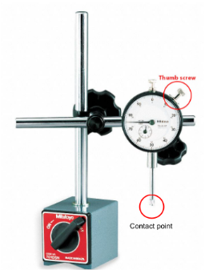

[reference image of contact point]

[pulse highlight dial indicator]
[Simon VO:] We’re gonna slide the rods so that the contact point touches the counterweight on the crankshaft. Touch the dial indicator and I’ll get it in place.

 | Action “Do” | Visual “See” | VO / SFX “Hear” | Haptic “Feel” | Dev Notes
Correct: | Touches dial indicator | [dial head snaps into ghost indicator position]  [end pulse highlight of dial indicator]  [State change: Needle has moved to the 5th tick mark] | [sfx confirmation]
If: | Idle | pulse highlight of dial indicator] | [Simon VO:] Touch the dial indicator.

[Simon VO:] See how the needle no longer points to zero? That’s because the contact point now touches the counterweight. I’ll tighten the positioning clamp.

[Magnify UI appears and its field is the entire dial, thumbscrew, and clamp on the rod behind it; it shouldn’t block the location of the pry bar]
[animate clamp on back of dial turning clockwise]

[Simon VO:] We need to set this dial indicator back to zero so we can get an accurate reading of the crankshaft’s end play.

[reference image of thumb screw]

[pulse highlight thumb screw]
[Simon VO:] This thumb screw secures the outer ring on the gauge. I’ll loosen it.
[animate thumb screw turning for 0.5 seconds]
[Simon VO:] Now you can rotate the face of the dial.
[shrink magnify UI to only cover face of dial]

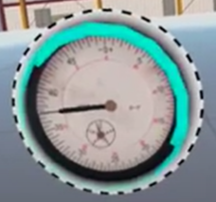
[reference image of outer ring]

[pulse highlight outer ring]

[Simon VO:] Gently grip the outer ring.
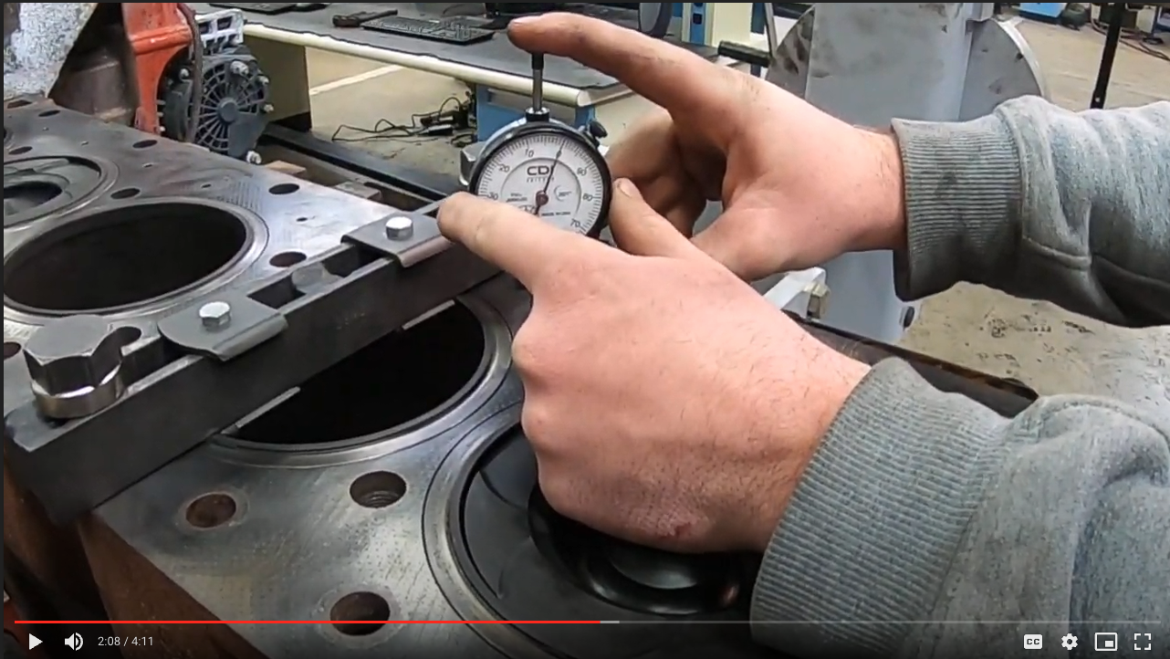
[reference image of grip]

 | Action “Do” | Visual “See” | VO / SFX “Hear” | Haptic “Feel” | Dev  Notes
Correct: | grips outer ring | [CW Hint UI arrows appear] | [sfx confirmation]
If: | idle |  | [Simon VO:] Gently grip the outer ring.

[Simon VO:] Rotate it until the zero lines up with the needle.

 | Action “Do” | Visual “See” | VO / SFX “Hear” | Haptic “Feel” | Dev Notes
Correct: | twists CW until needle lines up with zero | [Ring locks in place when it reaches zero]  [CW hint UI disappears] | [sfx confirmation]  [Simon VO:] Got it.
If: | idles |  | [Simon VO:] Rotate the outer ring until the zero lines up with the needle.

[Simon VO:] I’ll tighten the locking screw.
[animate the locking screw twisting clockwise]
[Simon VO:] Great job! Everything’s in place and ready to go.

5. Measure Crankshaft End Play (Tutorial)
Domain model success criteria: | Reach the end of this step.  (Do not add mistakes within this step.)

[Simon VO:] Before we take our measurement, let’s look at the specification chart.

[Appear chart floating above the cart].
Chart needs to be legible for trainee, so chart should be ½ meter wide.
Static highlight data points circled in reference image below]

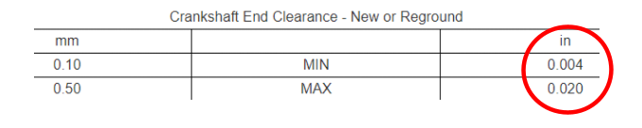
[Reference image of chart]

[Simon VO:] We’re looking for our end play to be between four thousandths and twenty thousandths of an inch.
[Simon VO:] If our measurement is under FOUR thousandths, we can adjust it to fit the spec.
[Simon VO:] But if it's over TWENTY thousandths, we'll need to replace the crankshaft.
[Appear pry bar on cart]
[Simon VO: ] We gotta move the crankshaft to the front of the engine block.
[pulse highlight pry bar]
[Simon VO:] Grab the pry bar.

 | Action “Do” | Visual “See” | VO / SFX “Hear” | Haptic “Feel” | Dev Notes
Correct: | Grabs pry bar | [chart disappears from over cart] | [sfx confirmation]
If: | Idle |  | [Simon VO:] Grab the pry bar.

[reference image of counterweights

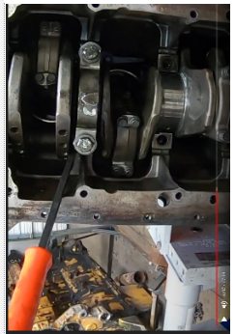

[reference image of pry bar wedged in between the counterweight (on top of the pry bar) and main bearing cap #3 (below the pry bar)]

[Ghost pry bar appears, positioned between the counterweight and bearing cap that’s easiest to access for trainee]
[Simon VO:] Put the pry bar where I’m showing you.

 | Action “Do” | Visual “See” | VO / SFX “Hear” | Haptic “Feel” | Dev Notes
Correct: | Puts pry bar on ghost pry bar | [UI left arrow appears as in the “before push” image below] | [sfx confirmation]
If: | Idle |  | [Simon VO:] Put the pry bar where I’m showing you.

Before push
After push
[reference image of pry bar pushing crankshaft toward rear of engine]

[Simon VO:] Great. Now, to shift the crankshaft to the front, push the pry bar handle towards the rear of the engine.

 | Action “Do” | Visual “See” | VO / SFX “Hear” | Haptic “Feel” | Dev Notes
Correct: | pushes pry bar to the left | [State change: needle moves slightly to .002 inches, or second tick mark to the left of zero] | [sfx metal clang]  [sfx confirmation]  [Simon VO:] Looks good to me! | [haptic feedback in controller holding pry bar]
If: | Pushes bar to the right |  | [Simon VO:] Oops! Not that way.
If: | Idle |  | [Simon VO:] Push the pry bar handle towards the rear of the engine.

[Simon VO:] Put your pry bar down on the cart.

 | Action “Do” | Visual “See” | VO / SFX “Hear” | Haptic “Feel” | Dev Notes
Correct: | Puts down pry bar on cart |  | [sfx confirmation]
If: | Idle |  | [Simon VO:] Put your pry bar on the cart.

[vanish pry bar]
[Simon VO:] Look at the dial. Each line represents a thousandth of an inch.
[Magnify UI of dial indicator appears above dial]
[Needle is pointing at the second line on the left of the zero]

reference image of dial; red arrow shows where the “two” line is.

[MC Question popup - text appears centered in front of trainee: “Is this measurement within specification?”]
[Simon VO:] Is this measurement within specification?
[choices on floating menu: not randomized
- Yes
- No

[Simon VO:] Touch the answer you think is correct.

 | Action “Do” | Visual “See” | VO / SFX “Hear” | Dev Notes
Correct: | touches response | [selected response highlights in blue]  [SUBMIT button appears]  [trainee has opportunity to change response]
If: | idle without touching a response |  | [Simon VO:] Touch the answer you think is correct.

[Simon VO:] Touch the submit button if that’s your response. You can change your answer if you want.
 | Action “Do” | Visual “See” | VO / SFX “Hear” | Dev Notes
Correct: | touches SUBMIT button  AND  submitted response B | [green border appears around B] | [sfx confirmation]  [Simon VO:] That’s right!
If: | idle after selecting a response, but without touching SUBMIT button |  | [Simon VO:] Touch the submit button if that’s your response. You can change your answer if you want.
 | touches SUBMIT button  AND  submitted response A | [green border appears around B] | [sfx buzzer]  [Simon VO:] That’s not right.

[Simon VO:] Two thousandths of an inch is not within spec.
[Simon VO:] If it were over TWENTY thousandths of an inch, we’d have to replace the crankshaft.
[Simon VO:] But we can adjust this one to get it within spec.

6. Resolve End Play being out of Specification (Tutorial)
Domain model success criteria: | Reach the end of this step.  (Do not add mistakes within this step.)

[Simon VO:] Let’s get the crankshaft’s end play within spec.
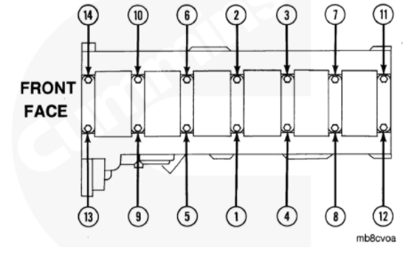
[reference image of main cap bolt numbering]

[floating numbers appear just above main cap bolts , labeling bolts as shown in reference image]
[Simon VO:] We need to loosen these main bearing bolts ONE turn each—in the right order.

[ratchet and 21mm socket appear on cart]
[Simon VO:] Here’s a ratchet with the socket you need.

[pulse highlight ratchet and socket]
[Simon VO:] Grab the ratchet.
 | Action “Do” | Visual “See” | VO / SFX “Hear” | Haptic “Feel” | Dev Notes
Correct: | grabs ratchet | [appear ghost ratchet and socket on bolt 1] | [sfx confirmation]
If: | Idle |  | [Simon VO:] Grab the ratchet.

[Simon VO:] Position the socket over the first bolt.

 | Action “Do” | Visual “See” | VO / SFX “Hear” | Haptic “Feel” | Dev Notes
Correct: | Puts socket on bolt #1 | [counterclockwise hint UI appears] | [sfx confirmation]
If: | Idle |  | [Simon VO:] Position the socket over the first bolt.

[Simon VO:] Rotate the handle counterclockwise to loosen the bolt. This is a ratcheting tool, so you can wind it back and push it again.

 | Action “Do” | Visual “See” | VO / SFX “Hear” | Haptic “Feel” | Dev Notes
Correct: | twists counterclockwise until bolt rotates 100 degrees | WHILE TURNING: [counterclockwise hint UI moves counterclockwise]  [bolt turns]  WHEN COMPLETE:  [counterclockwise hint UI disappears] | [sfx confirmation]
If: | Doesn’t turn far enough and is idle |  | [Simon VO:] Keep turning. You’re almost there.
If: | winds wrench back, clockwise | [counterclockwise hint UI holds still ]  [socket portion of the wrench holds still] | [sfx ratcheting]
If: | Idle |  | [Simon VO:] Rotate the handle counterclockwise to loosen the bolt.

[Simon VO:] Nice work! I’ll loosen the rest of these bolts. First, let me take that ratchet.

[vanish ratchet and socket from trainee hands]

[reappear ratchet over engine and animate it for .5 seconds each turning all other screws 360 degrees counterclockwise in number order, starting with screw 2 and ending with 14]
[sfx confirmation after all screws are loosened]
[vanish ratchet and socket]

[Simon VO:] All right. Now we need to torque these to a hundred and fifty foot-pounds.

[appear digital torque wrench with 21mm socket on cart, set to 150 foot-pounds]
[pulse highlight digital torque wrench and socket]

[Simon VO:] Grab the torque wrench.

 | Action “Do” | Visual “See” | VO / SFX “Hear” | Haptic “Feel” | Dev Notes
Correct: | Picks up torque wrench | [Appear ghost torque wrench over bolt 1] | [sfx confirmation]
If: | Idle |  | [Simon VO:] Grab the torque wrench.

[Simon VO:] Fit the socket over the first bolt.

 | Action “Do” | Visual “See” | VO / SFX “Hear” | Haptic “Feel” | Dev Notes
Correct: | Fits torque wrench over bolt #1 | [wrench snaps on]  [wrench’s yellow lights light up on contact]  [CW hint UI appears] | [sfx confirmation]
If: | Idle | [pulse highlight bolt #1] | [Simon VO:] Fit the socket over the first bolt.
If: | Puts ratchet and socket on bolts #2, 3, or 4 | [pulse highlight bolt #1] | [Simon VO:] Fit the socket over this first bolt.

[Simon VO:] Rotate the handle clockwise to tighten the bolt.

 | Action “Do” | Visual “See” | VO / SFX “Hear” | Haptic “Feel” | Dev Notes
Correct: | Twists handle CW 100 degrees | [Once twists 100 degrees:  CW hint UI disappears] | [sfx confirmation]
If: | idle |  | [Simon VO:] Rotate the handle clockwise to tighten the bolt.
If: | idle after starting to turn CW, but does not complete 100 degrees rotation |  | [Simon VO] Keep turning. You’re almost there.
If: | winds wrench CCW | [CW hint holds still]  AND  [socket portion of the wrench holds still] | [sfx ratcheting]

[Simon VO:] Okay, great. Put the torque wrench on the cart.

 | Action “Do” | Visual “See” | VO / SFX “Hear” | Haptic “Feel” | Dev Notes
Correct: | puts torque wrench on cart |  | [sfx confirmation]
If: | Idle |  | [Simon VO:] Put the torque wrench on the cart.

[vanish digital torque wrench from cart]
[Simon VO:] I’ll tighten the other bolts.
[reappear digital torque wrench over engine and animate it for 0.5 -1 second TOTAL turning all other screws 100 degrees clockwise]
[sfx confirmation after all screws tightened]

[Simon VO:] That’ll do it!
[vanish digital torque wrench]

[Simon VO:] All right; now, let’s recheck that end play.
[Pry bar appears on cart]
[reference image of pry bar]

[pulse highlight pry bar]
[Simon VO:] Pick up the pry bar.
 | Action “Do” | Visual “See” | VO / SFX “Hear” | Haptic “Feel” | Dev Notes
Correct: | Picks up pry bar | [Ghost pry bar appears between any counterweight and main bearing cap; pry bar handle tilts to the left] | [Sfx confirmation]
If: | Idle |  | [Simon VO:] Pick up the pry bar.

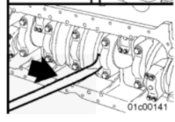

[Simon VO:] Put the pry bar where I’m showing you.

 | Action “Do” | Visual “See” | VO / SFX “Hear” | Haptic “Feel” | Dev Notes
Correct: | Places pry bar near ghost | [Stationary hint UI arrow appears as shown in image above] | [Sfx confirmation]
If: | Idle |  | [Simon VO:] Put the pry bar where I’m showing you.

[Simon VO:] Great. Push the handle of the pry bar to the right.

 | Action “Do” | Visual “See” | VO / SFX “Hear” | Haptic “Feel” | Dev Notes
Correct: | Pushes pry bar to the right | [pry bar locks in place]  [Magnify UI of dial indicator appears above dial]  [state change: needle points to 2] | [sfx metal clang]  [Sfx confirmation] | [haptic feedback in controller holding the pry bar]
If: | Pushes pry bar to the left |  | [Simon VO:] Oops! Not that way.
If: | Idle |  | [Simon VO:] Push the handle of the pry bar to the right.

[Simon VO:] The needle needs to be at zero before we measure anything. I’ll zero it.
[Animate dial turning back to zero AFTER Simon’s VO]
[pry bar returns to cart]

[Simon VO:] Let’s shift the crankshaft again and measure its movement.
[Simon VO:] Grab the pry bar.

 | Action “Do” | Visual “See” | VO / SFX “Hear” | Haptic “Feel” | Dev Notes
Correct: | Grabs pry bar | [ghost pry bar appears; see reference image below] | [SFX confirmation]
If: | Idle |  | [Simon VO:] Grab the pry bar.

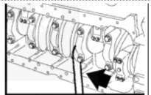
[Reference image of position of ghost pry bar and direction of its handle]

[Simon VO:] Put the pry bar where I’m showing you.

 | Action “Do” | Visual “See” | VO / SFX “Hear” | Haptic “Feel” | Dev Notes
Correct: | Places pry bar near ghost | [Stationary hint UI arrow appears as shown in image above] | [SFX confirmation]
If: | Idle |  | [Simon VO:] Put the pry bar where I’m showing you.

[Simon VO:] Push the pry bar to the left.

[reference image of twelfth tick mark on dial face]

 | Action “Do” | Visual “See” | VO / SFX “Hear” | Haptic “Feel” | Dev Notes
Correct: | Pushes pry bar to the left | [pry bar snaps in place]  [Magnify UI of dial indicator appears above dial]  [state change: needle points to the twelfth tick mark as in reference image above] | [SFX confirmation]  [sfx metal clank] | [haptic feedback]
If: | Pushes pry bar to the right |  | [Simon VO:] Oops! Not that way.
If: | Idle |  | [Simon VO:] Push the pry bar to the left.

[Simon VO:] Okay, great. Put the pry bar on the cart.

 | Action “Do” | Visual “See” | VO / SFX “Hear” | Haptic “Feel” | Dev Notes
Correct: | puts torque wrench on cart |  | [sfx confirmation]
If: | Idle |  | [Simon VO:] Put the torque wrench on the cart.

[Simon VO:] Look at the dial.
[Magnify UI appears above dial]
[needle points to twelfth tick mark as shown in reference image above]
[reference image of crankshaft spec chart]
[appear crankshaft spec chart including red circle]
[MC question popup–text appears centered in front of the trainee: “Is this within specification?”
[Simon VO:] Is this within specification?
[choices on floating menu–not randomized]
- Yes
- No]

 | Action “Do” | Visual “See” | VO / SFX “Hear” | Haptic “Feel” | Dev Notes
Correct: | Touches either response | [selected response highlights in blue]  [SUBMIT button appears]  [trainee has opportunity to change response]
If: | Idle without touching a response |  | [Simon VO:] Touch the answer you think is correct.

[Simon VO:] Touch the submit button if that’s your response. You can change your answer if you want.

 | Action “Do” | Visual “See” | VO / SFX “Hear” | Haptic “Feel” | Dev Notes
Correct: | touches SUBMIT button  AND  submitted response A | [green border appears around A] | [sfx confirmation]  [Simon VO:] That’s right!
If: | idle after selecting a response, but without touching SUBMIT button |  | [Simon VO:] Touch the submit button if that’s your response. You can change your answer if you want.
 | touches SUBMIT button  AND  submitted response B | [green border appears around A] | [sfx buzzer]  [Simon VO:] That’s not right.

[Simon VO:] The end play of this crankshaft is TWELVE thousandths of an inch. That falls within spec!
[Simon VO:] Awesome job measuring and resolving crankshaft end play!

[all floating text disappears]

Hands-on Practice

7. Transition to HOP (HOP)
Domain model success criteria: | Reach the end of this step.  (Do not add mistakes within this step.)
[Playspace: A]
[Simon VO:] Now it’s time to try it on your own. You’ll be scored for this part, and I’ll be here if you get stuck, but you’ll lose points if I have to help.

8. PPE (HOP)
Domain model success criteria: | Reach the end of this step with 0 mistakes.

Developers and VO Maintenance: Please insert the PPE (HOP) from the Diesel 2: PPE and Engine Rotation Standards document.

9. Prepare Crankshaft for Measurement (HOP)

Domain model success criteria: | Reach the end of this storyboard step with <= 1 mistake.

[all the tools we’ll need appear on the left side of the table:
- Magnetic base and dial indicator assembly
- Pry bar
- Ratchet and socket
- Socket
- Digital torque wrench]
[Simon VO:] Before we can install the magnetic base and dial indicator, we need to shift something.
[Simon VO:] Grab the tool you need to use.

 | Action “Do” | Visual “See” | VO / SFX “Hear” | Haptic “Feel” | Dev Notes
Correct: | Picks up pry bar |  | [sfx confirmation]
If: | Idle | [pulse highlight pry bar] | [Simon VO:] Pick up the pry bar. |  | [addMistake]

 | Action “Do” | Visual “See” | VO / SFX “Hear” | Haptic “Feel” | Dev Notes
Correct: | Puts pry bar in same location as in the tutorial |  | [sfx confirmation]
If: | Idle | [appear ghost pry bar in correct pry bar position] | [Simon VO:] Put the pry bar here. |  | [addMistake]

 | Action “Do” | Visual “See” | VO / SFX “Hear” | Haptic “Feel” | Dev Notes
Correct: | Pushes bar to the right | [animation: crankshaft shifts toward the rear of the engine about one inch] | [sfx confirmation]  [sfx metal clang] | [haptic feedback in controller holding pry bar]
If: | Idle | [stationary hint UI right arrow appears above pry bar] | [Simon VO:] Push the pry bar to the right to shift the crankshaft |  | [addMistake]

[Simon VO:] Put down the pry bar.

 | Action “Do” | Visual “See” | VO / SFX “Hear” | Haptic “Feel” | Dev Notes
Correct: | Puts down pry bar |  | [sfx confirmation]  [sfx metal clang]
If: | Idle |  | [Simon VO:] Put down the pry bar.

10. Activate and Place Dial Indicator (HOP)

Domain model success criteria: | Reach the end of this storyboard step with fewer than <= 2 mistakes.

[Simon VO:] What tool do you use next?

 | Action “Do” | Visual “See” | VO / SFX “Hear” | Haptic “Feel” | Dev Notes
Correct: | Picks up dial indicator and magnetic base assembly |  | [sfx confirmation]
If: | idle | [pulse highlight dial indicator and magnetic base] | [Simon VO:] Pick up the dial indicator and magnetic base. |  | [addMistake]

 | Action “Do” | Visual “See” | VO / SFX “Hear” | Haptic “Feel” | Dev Notes
Correct: | Puts assembly in correct location | [dial indicator/magnetic base assembly “snaps” into place] | [sfx confirmation]
If: | idle | [appear ghost dial indicator/magnetic base assembly on engine] | [Simon VO:] Put the dial indicator and magnetic base here. |  | [addMistake]

 | Action “Do” | Visual “See” | VO / SFX “Hear” | Haptic “Feel” | Dev Notes
Correct: | grabs the knob on the magnetic base |  | [sfx confirmation]
If: | Idle | [pulse highlight knob on magnetic base] | [Simon VO:] Grab the knob on the magnetic base. |  | [addMistake]

 | Action “Do” | Visual “See” | VO / SFX “Hear” | Haptic “Feel” | Dev Notes
Correct: | Rotates knob counter-clockwise until it’s set to ON | [knob snaps into place pointing to ON and won’t move farther] | [sfx confirmation]
If: | Idle |  | [Simon VO:] Turn on the magnetic base by switching the knob to ON. |  | [addMistake]

[reference image showing correct placement of dial indicator assembly]

[Simon VO:] Touch the dial indicator and I’ll get it in place.

 | Action “Do” | Visual “See” | VO / SFX “Hear” | Haptic “Feel” | Dev Notes
Correct: | Touches contact point | [dial head snaps into ghost indicator position]  [State change: Needle has moved to the 5th tick mark]  [Magnify UI appears above dial, but not blocking location of prybar, and will stay throughout the rest of the sim] | [sfx confirmation]
If: | Idle | pulse highlight of dial indicator] | [Simon VO:] Touch the dial indicator and I’ll get it in place. |  | [addMistake]

[Simon VO:] I’ll tighten the positioning clamp and loosen the thumb screw. How do we get the needle back to zero?

 | Action “Do” | Visual “See” | VO / SFX “Hear” | Haptic “Feel” | Dev  Notes
Correct: | grips outer ring |  | [sfx confirmation]
If: | idle | [pulse highlight outer ring] | [Simon VO:] Gently grip the outer ring. |  | [addMistake]

 | Action “Do” | Visual “See” | VO / SFX “Hear” | Haptic “Feel” | Dev Notes
Correct: | twists CW until needle lines up with zero | [Ring locks in place when it reaches zero] | [sfx confirmation]
If: | idle |  | [Simon VO:] Rotate the outer ring until the zero lines up with the needle. |  | [addMistake]

[animate the locking screw twisting clockwise]
[Simon VO:] Great job!

11. Measure Crankshaft End Play (HOP)

Domain model success criteria: | Reach the end of this storyboard step with <= 1 mistake.  AND  Submit multiple choice question with 0 errors

[Simon VO:] Time to measure crankshaft end play. Show me how.

 | Action “Do” | Visual “See” | VO / SFX “Hear” | Haptic “Feel” | Dev Notes
Correct: | Grabs pry bar |  | [sfx confirmation]
If: | Idle | [pulse highlight pry bar] | [Simon VO:] Grab the pry bar. |  | [addMistake]

 | Action “Do” | Visual “See” | VO / SFX “Hear” | Haptic “Feel” | Dev Notes
Correct: | Puts pry bar in correct position, between counterweight and main bearing cap |  | [sfx confirmation]
If: | Idle | [Ghost pry bar appears, positioned between the counterweight and bearing cap that’s easiest to access for trainee] | [Simon VO:] Put the pry bar here. |  | [addMistake]

 | Action “Do” | Visual “See” | VO / SFX “Hear” | Haptic “Feel” | Dev Notes
Correct: | pushes pry bar to the left | [state change: needle moves slightly to .001 inches] | [sfx metal clang]  [sfx confirmation] | [haptic feedback in controller holding pry bar]
If: | Idle | [UI left arrow appears above pry bar] | [Simon VO:] Push the pry bar handle towards the rear of the engine. |  | [addMistake]
 | Pushes pry bar to the right |  | [Simon VO:] Oops! Not that way. |  | [addMistake]

[Simon VO:] Now, put your pry bar down on the cart.

 | Action “Do” | Visual “See” | VO / SFX “Hear” | Haptic “Feel” | Dev Notes
Correct: | Puts down pry bar on cart |  | [sfx confirmation]
If: | Idle |  | [Simon VO:] Put the pry bar down on the cart.

[Appear chart floating above the cart].
Chart needs to be legible for trainee, so chart should be ½ meter wide.
Static highlight data points circled in reference image below]

[Reference image of chart]

[pulse highlight dial, still at .001 inches]

[Simon VO:] Look at the dial.

[end pulse highlight dial]

[MC Question popup - text appears centered in front of trainee: “Is this measurement within specification?”]

[Simon VO:] Is this measurement within specification?

[choices on floating menu, not randomized:]
- Yes
- No]

[Simon VO:] Touch the answer you think is correct.

 | Action “Do” | Visual “See” | VO / SFX “Hear” | Dev Notes
Correct: | touches response | [selected response highlights in blue]  [SUBMIT button appears]  [trainee has opportunity to change response]
If: | idle without touching a response |  | [Simon VO:] Touch the answer you think is correct.

[Simon VO:] Touch the submit button if that’s your response. You can change your answer if you want.
 | Action “Do” | Visual “See” | VO / SFX “Hear” | Dev Notes
Correct: | touches SUBMIT button  AND  submitted response B | [green border appears around B] | [sfx confirmation]  [Simon VO:] That’s right!
If: | idle after selecting a response, but without touching SUBMIT button |  | [Simon VO:] Touch the submit button if that’s your response. You can change your answer if you want.
 | touches SUBMIT button  AND  submitted response A | [green border appears around B] | [sfx buzzer]  [Simon VO:] That’s not right. | [addMistake]

[Simon VO:] One one-thousandth of an inch is not within spec.

12 Resolve End Play being Out of Specification (HOP)

Domain model success criteria: | Reach the end of this storyboard step with <= 3 mistakes.  AND  Submit multiple choice question with 0 errors

[Simon VO:] Let’s get the crankshaft’s end play within spec.
[reference image of main cap bolt numbering]

[floating numbers appear just above main cap bolts, labeling bolts as shown in reference image]

[Simon VO:] Show me how.

 | Action “Do” | Visual “See” | VO / SFX “Hear” | Haptic “Feel” | Dev Notes
Correct: | grabs ratchet |  | [sfx confirmation]
If: | Idle | [pulse highlight ratchet] | [Simon VO:] Grab the ratchet. |  | [addMistake]

 | Action “Do” | Visual “See” | VO / SFX “Hear” | Haptic “Feel” | Dev Notes
Correct: | brings ratchet and socket to bolt #1 | [counterclockwise hint UI appears] | [sfx confirmation]
If: | Idle | [pulse highlight bolt #1] | [Simon VO:] Fit the socket over this first bolt. |  | [addMistake]

 | Action “Do” | Visual “See” | VO / SFX “Hear” | Haptic “Feel” | Dev Notes
Correct: | twists counterclockwise to rotate the bolt 100 degrees | WHILE TURNING:  [bolt appears to turn 360 degrees]  WHEN COMPLETE:  [counterclockwise hint UI disappears] | [sfx confirmation]
If: | starts but does not finish turning 100 degrees and is idle |  | [Simon VO:] Keep turning. You’re almost there.
If: | winds wrench back, clockwise |  | [sfx ratcheting]
If: | Idle |  | [Simon VO:] Twist the ratchet counterclockwise to loosen the bolt. |  | [addMistake]

[Simon VO:] Nice work! I’ll loosen the rest of these bolts. First, let me take that ratchet.

[vanish ratchet and socket from trainee hands]
[reappear ratchet over engine and animate it for 2 seconds total turning all other screws 360 degrees counterclockwise in number order, starting with screw 2 and ending with 14]
[sfx confirmation after all screws are loosened]
[ratchet and socket re-appear on cart]

[Simon VO:] All right. Now we need to torque these to a hundred and fifty foot-pounds.
[Simon VO:] Grab the tool you need.

 | Action “Do” | Visual “See” | VO / SFX “Hear” | Haptic “Feel” | Dev Notes
Correct: | Picks up torque wrench |  | [sfx confirmation]
If: | Idle | [pulse highlight torque wrench] | [Simon VO:] Grab the torque wrench. |  | [addMistake]

 | Action “Do” | Visual “See” | VO / SFX “Hear” | Haptic “Feel” | Dev Notes
Correct: | Fits torque wrench over first bolt | [wrench snaps on]  [wrench’s yellow lights light up on contact] | [sfx confirmation]
If: | Idle | [pulse highlight bolt #1] | [Simon VO:] Fit the socket over this first bolt. |  | [addMist  ake]
If: | Puts ratchet and socket on any bolt besides #1 or #2 | [pulse highlight bolt #1] | [Simon VO:] Fit the socket over this first bolt |  | [addMistake]

[Simon VO:] Good. What next?

 | Action “Do” | Visual “See” | VO / SFX “Hear” | Haptic “Feel” | Dev Notes
Correct: | Twists handle CW 100 degrees |  | [sfx confirmation]
If: | idle |  | [Simon VO:] Rotate the handle clockwise to tighten the bolt. |  | [addMistake]
If: | idle after starting to turn CW, but does not complete 100 degrees rotation |  | [Simon VO] Keep turning. You’re almost there.
If: | winds wrench CCW | [socket portion of the wrench holds still] | [sfx ratcheting]

[Simon VO:] Okay, great. Put the torque wrench down on the cart.

 | Action “Do” | Visual “See” | VO / SFX “Hear” | Haptic “Feel” | Dev Notes
Correct: | puts torque wrench on cart |  | [sfx confirmation]
If: | Idle |  | [Simon VO:] Put the torque wrench down on the cart. |  | [addMistake]

[Simon VO:] I’ll tighten the other bolts.
[reappear digital torque wrench over engine and animate it for 0.5 -1 second TOTAL turning all other screws 100 degrees clockwise]

[sfx confirmation after all screws tightened]

[Simon VO:] All right! Now let’s recheck that end play.

 | Action “Do” | Visual “See” | VO / SFX “Hear” | Haptic “Feel” | Dev Notes
Correct: | Picks up pry bar |  | [Sfx confirmation]
If: | Idle | [pulse highlight pry bar] | [Simon VO:] Pick up the pry bar. |  | [addMistake]

[Simon VO:] Put it where it goes and shift the crankshaft to the rear of the engine.

 | Action “Do” | Visual “See” | VO / SFX “Hear” | Haptic “Feel” | Dev Notes
Correct: | Places pry bar in correct location |  | [Sfx confirmation]
If: | Idle | [Ghost pry bar appears between any counterweight and main bearing cap; pry bar handle tilts to the left] | [Simon VO:] Put the pry bar here. |  | [addMistake]

 | Action “Do” | Visual “See” | VO / SFX “Hear” | Haptic “Feel” | Dev Notes
Correct: | Pushes pry bar to the right | [pry bar locks in place]  [Magnify UI of dial indicator appears above dial]  [state change:needle points to 2] | [sfx metal clang]  [Sfx confirmation] | [haptic feedback in controller holding the pry bar]
If: | Idle | [Appear static right-facing arrow above pry bar] | [Simon VO:] Push the pry bar to the right. |  | [addMistake]
If: | Pushes pry bar to the left | [Appear static right-facing arrow above pry bar] | [Simon VO:] Try the other way. |  | [addMistake]

[Simon VO:] I’ll zero the dial indicator.
[Animate dial turning back to zero]
[Simon VO:] Shift the crankshaft again and measure its movement.
[Note: the pry bar is still in the trainee’s hand.]

 | Action “Do” | Visual “See” | VO / SFX “Hear” | Haptic “Feel” | Dev Notes
Correct: | Places pry bar in correct position |  | [SFX confirmation]
If: | Idle | [ghost pry bar appears in correct location] | [Simon VO:] Place the pry bar here. |  | [addMistake]

 | Action “Do” | Visual “See” | VO / SFX “Hear” | Haptic “Feel” | Dev Notes
Correct: | Pushes pry bar to the left | [pry bar locks in place]  [Magnify UI of dial indicator appears above dial]  [Needle points to the fifteenth tick mark] | [SFX confirmation]  [sfx metal clank] | [haptic feedback]
If: | Idle | [Appear static left-facing arrow] | [Simon VO:] Push the pry bar handle to the left. |  | [addMistake]
If: | Pushes pry bar to the right | [Appear static left-facing arrow above pry bar] | [Simon VO:] Try the other way. |  | [addMistake]

[Simon VO:] Okay, great. Put the torque wrench down on the cart.

 | Action “Do” | Visual “See” | VO / SFX “Hear” | Haptic “Feel” | Dev Notes
Correct: | puts torque wrench down on cart |  | [sfx confirmation]
If: | Idle |  | [Simon VO:] Put the torque wrench down on the cart.

[Simon VO:] Look at the dial.
[Specs chart appears above the engine]
[MC question popup–text appears centered in front of the trainee: “Is this within specification?”
[Simon VO:] Is this within specification?
[choices on floating menu, not randomized:
- Yes
- No]

 | Action “Do” | Visual “See” | VO / SFX “Hear” | Haptic “Feel” | Dev Notes
Correct: | Touches either response | [selected response highlights in blue]  [SUBMIT button appears]  [trainee has opportunity to change response]
If: | Idle without touching a response |  | [Simon VO:] Touch the answer you think is correct.

[Simon VO:] Touch the submit button if that’s your response. You can change your answer if you want.

 | Action “Do” | Visual “See” | VO / SFX “Hear” | Haptic “Feel” | Dev Notes
Correct: | touches SUBMIT button  AND  submitted response A | [green border appears around A] | [sfx confirmation]  [Simon VO:] That’s right!
If: | idle after selecting a response, but without touching SUBMIT button |  | [Simon VO:] Touch the submit button if that’s your response. You can change your answer if you want.
 | touches SUBMIT button  AND  submitted response B | [green border appears around A] | [sfx buzzer]  [Simon VO:] That’s not right. |  | [addMistake]

[reference image of crankshaft spec chart]

[Simon VO:] The amount of end play in this crankshaft is fifteen-thousandths of an inch. That falls within spec! Great work measuring and resolving the crankshaft end play!

13. End of Sim (HOP)

 | Action | Visual | VO / SFX | Dev Notes
Correct: | achieved mastery | [medal appears, according to Domain Model scoring logic]  [trainee grabs medal to exit sim] | [Simon VO:] Congratulations! You just earned a gold/silver/bronze medal. Grab it to unlock it.
If: | did not achieve mastery | [display end screen without medal; instead there are two buttons: MAIN MENU and RETRY]  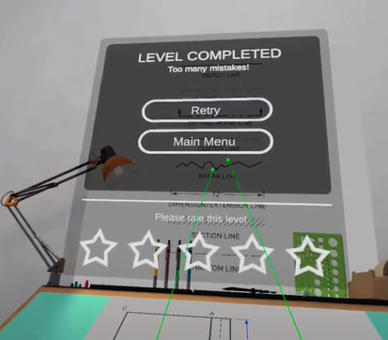 | [Simon VO:] Looks like you need more practice to earn a medal. Select MAIN MENU to exit the simulation or RETRY to try again.

References:
- Piston Cooling Nozzle Replacement
- Removing piston
- Jeremy’s piston removal

